Databases Enhancement – Grazioso Salvare Rescue Dog Dashboard
Brandon Shank
Date: 06/03/2026

Artifact Description
I worked on the Grazioso Salvare Rescue Dog Dashboard application, which I originally created in CS-340. The purpose of this system is to allow users to search, filter, and visualize animal rescue data stored in a MongoDB database through an interactive dashboard interface.
The application combines Python, MongoDB, Jupyter Dash, Plotly, and Dash Leaflet to create a full-stack database-driven dashboard system. The project uses a custom CRUD Python module to communicate with the MongoDB database and retrieve animal rescue information dynamically instead of relying on static or locally stored data.
The original version of the system allowed users to filter animals based on rescue categories such as water rescue, mountain rescue, and disaster rescue. The dashboard also included an interactive data table, breed visualization graphs, and a geographic map showing the location of selected animals. These features allowed users to interact with and visualize rescue information directly from the MongoDB database through the dashboard interface.
While the original implementation successfully demonstrated database connectivity, CRUD operations, and dashboard interaction, several areas of the project could still be improved related to maintainability, filtering logic, validation, performance, scalability, and database organization.
Because of these limitations, the project was a strong candidate for enhancement.

Justification for Inclusion and Enhancements
I selected this project because it demonstrates practical database integration, CRUD operations, interactive filtering, and full-stack communication between a database system and a user interface. The project also demonstrates how database systems can be integrated into interactive applications that allow users to manipulate and visualize large amounts of information dynamically.
Another reason I selected this artifact is because the original implementation provided several opportunities for meaningful improvement beyond simply changing the visual appearance of the application. While the dashboard functioned correctly, the internal database structure and filtering logic could be improved significantly.
For the updated version, I focused on improving the database structure, maintainability, scalability, filtering logic, validation, and overall organization of the application. Some of the main changes I made include:
• Reorganized database filtering logic into reusable database-layer functions inside the CRUD Python module.
• Added flexible filtering methods using the find_with_filters() function.
• Added rescue-specific reusable query handling using the rescue_filter() method.
• Improved database performance by implementing MongoDB indexing for commonly searched fields.
• Added aggregation support for breed and outcome analysis using MongoDB aggregation pipelines.
• Added stronger validation logic to improve data integrity and reduce invalid database operations.
• Added additional exception handling and error management to improve reliability and stability.
• Improved maintainability by separating dashboard interface logic from database query logic.
• Improved scalability by creating reusable and modular database-layer methods that can support future expansion.
• Added clearer organization and documentation throughout the project to improve readability and maintainability.
These enhancements helped transform the project from a basic database dashboard into a more structured, scalable, maintainable, and professionally organized database-driven application.

Course Outcomes
This enhancement helped demonstrate how databases, filtering systems, query optimization, and full-stack integration can be used to create scalable and maintainable software systems. The project demonstrates the ability to design and evaluate computing solutions that involve storing, manipulating, retrieving, and visualizing data from a MongoDB database.
One of the primary goals of this enhancement was improving maintainability and scalability, and I was able to accomplish that by restructuring the database logic into reusable methods inside the CRUD Python module. Separating database logic from dashboard interface logic improved modularity and created a cleaner software architecture.
The updated implementation also demonstrated the use of modern tools and technologies including MongoDB, Python, Jupyter Dash, Plotly, Dash Leaflet, and aggregation pipelines. These technologies allowed the dashboard to dynamically update tables, graphs, and maps based on filtered database records.
Another important outcome demonstrated through this enhancement was improving database performance and reliability. Implementing indexing improved query efficiency and filtering speed, while validation and exception handling improved data integrity and application stability. These enhancements helped prepare the application to handle larger datasets more efficiently while improving overall system reliability.
The enhancement also demonstrated practical database optimization concepts including reusable filtering methods, aggregation support, indexing, query abstraction, and modular software design principles.
Overall, the project demonstrates the ability to apply database concepts, software engineering principles, query optimization techniques, and full-stack integration to create a more professional and scalable application.

Reflection
One thing that stood out to me during this enhancement was how important organization and modularity are when developing database-driven applications. In the original implementation, much of the database query logic was embedded directly inside the dashboard code itself. While the application functioned correctly, this approach made the system harder to maintain, expand, and reuse as additional functionality was added.
By moving filtering and query handling into reusable database-layer methods inside the CRUD Python module, I was able to significantly improve the maintainability and structure of the project. Separating the dashboard interface from the database operations created a cleaner and more scalable design that better reflects professional software engineering practices.
Another major improvement involved implementing indexing and aggregation support. Before this enhancement, the project relied mainly on basic MongoDB queries without additional optimization. Adding indexes to commonly searched fields improved filtering performance and demonstrated how database optimization techniques can improve scalability as datasets grow larger.
I also learned how important validation and exception handling are when working with databases. The original implementation focused primarily on functionality, but during testing I realized that invalid queries and unexpected database issues could create reliability problems if they were not properly handled. Adding validation and exception handling improved the overall stability and reliability of the application.
One challenge I faced during this enhancement was balancing dashboard functionality with backend organization. Because the dashboard relies heavily on dynamic updates between tables, graphs, and maps, restructuring the filtering logic required careful testing to ensure all dashboard components continued updating correctly after the database changes were implemented.
Another challenge involved configuring and troubleshooting MongoDB queries and ensuring that the dashboard callbacks updated correctly after introducing reusable filtering methods and aggregation support.
Overall, this enhancement improved my understanding of database integration, query optimization, MongoDB indexing, aggregation pipelines, modular software architecture, dashboard interaction, validation, debugging, and scalable application development. It also demonstrated the importance of maintainability, organization, and performance optimization when improving existing database-driven systems.

Evidence (Screenshots)

Figure 1: Dashboard Overview
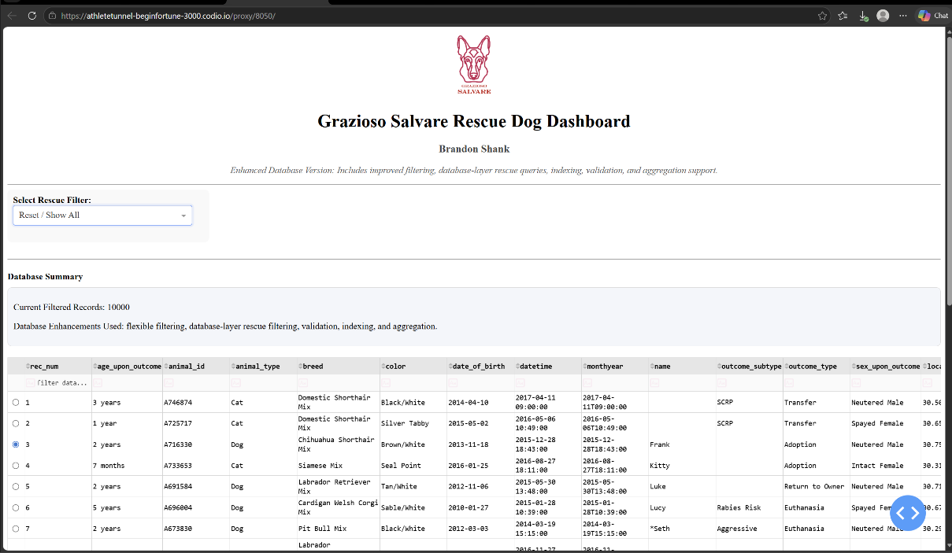
Enhanced Grazioso Salvare Rescue Dog Dashboard showing the updated interactive interface, filtering system, graph visualization, and integrated geographic mapping functionality.

Figure 2: Graph and Map Update
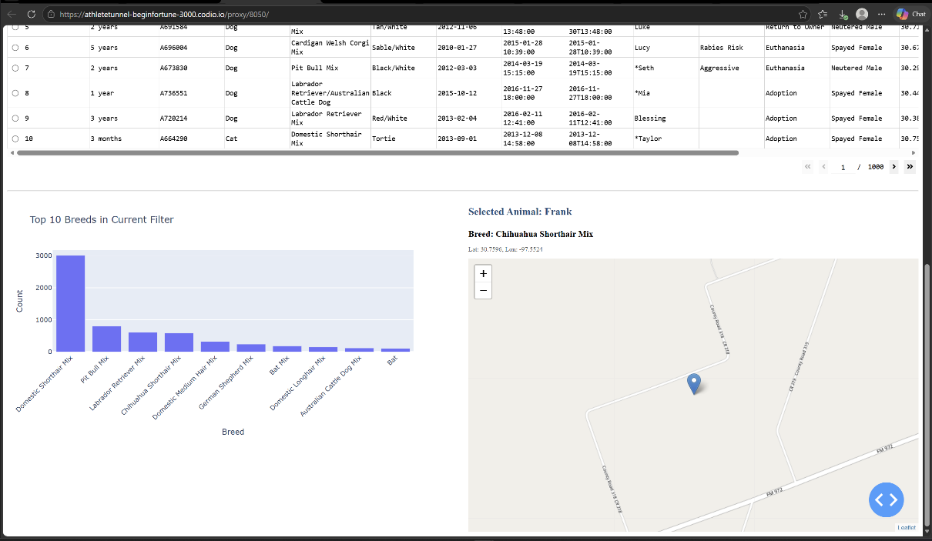
Dashboard visualization demonstrating dynamic graph and map updates after selecting and filtering rescue records from the MongoDB database.

Figure 3: Filtered Table Results
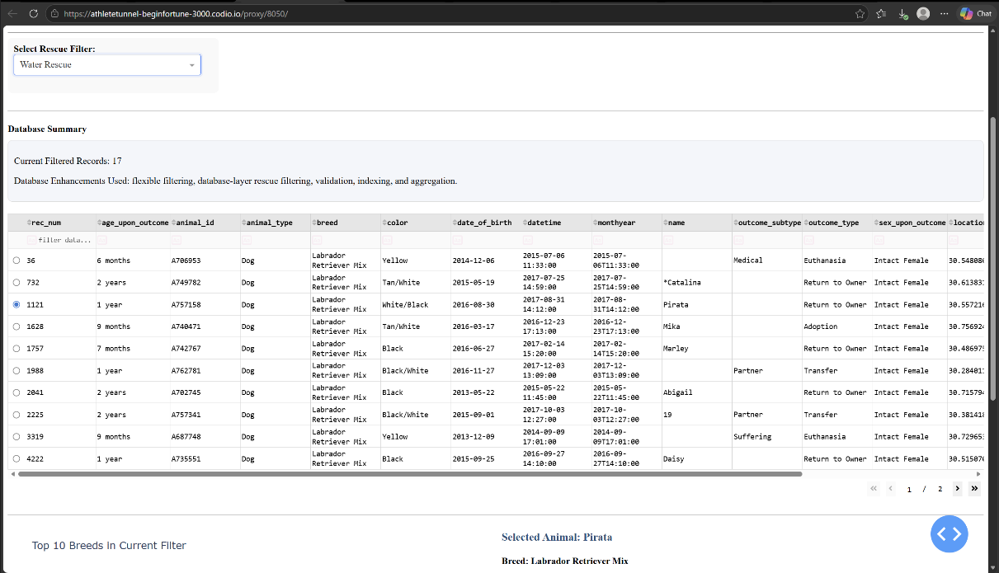
Interactive database table showing filtered MongoDB rescue records dynamically updating based on selected rescue categories.

Figure 4: Map Visualization Update
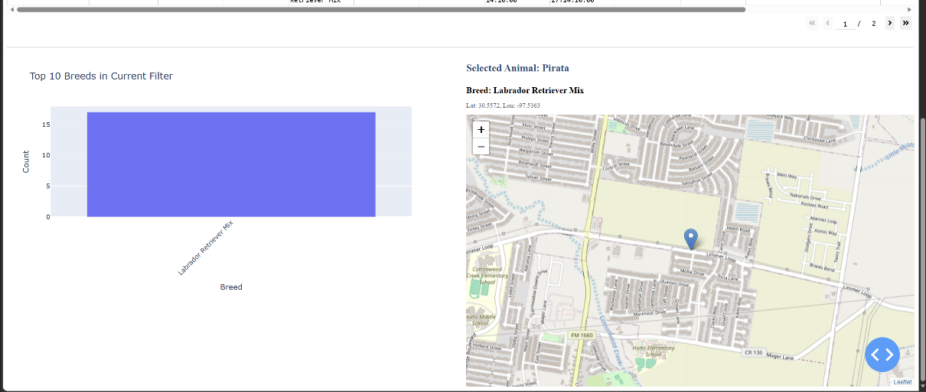
Interactive Dash Leaflet map demonstrating geographic location updates based on selected animal records within the dashboard table.

Figure 5: Graph and Map Filter Results
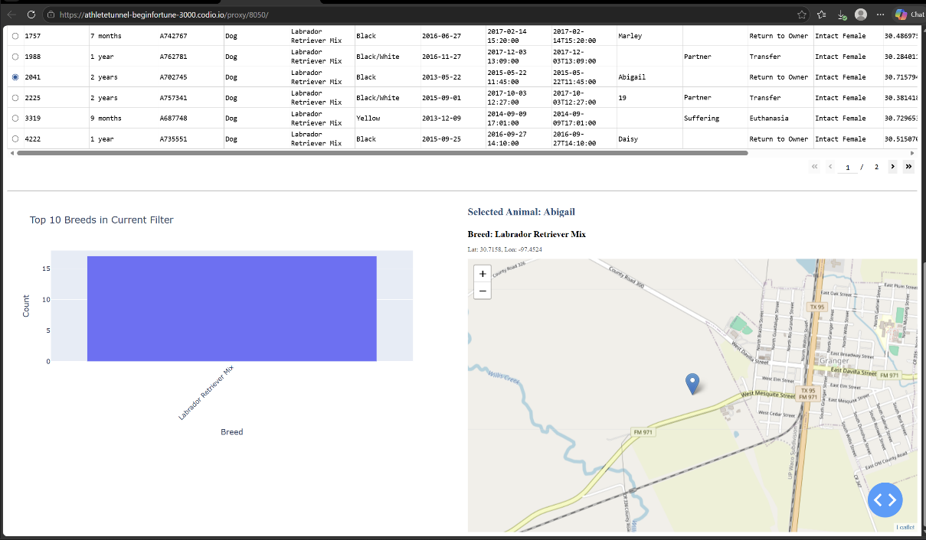
Updated dashboard graph and map output demonstrating integrated filtering functionality and synchronized visualization updates across dashboard components.

Figure 6: Full Dashboard Filter Example
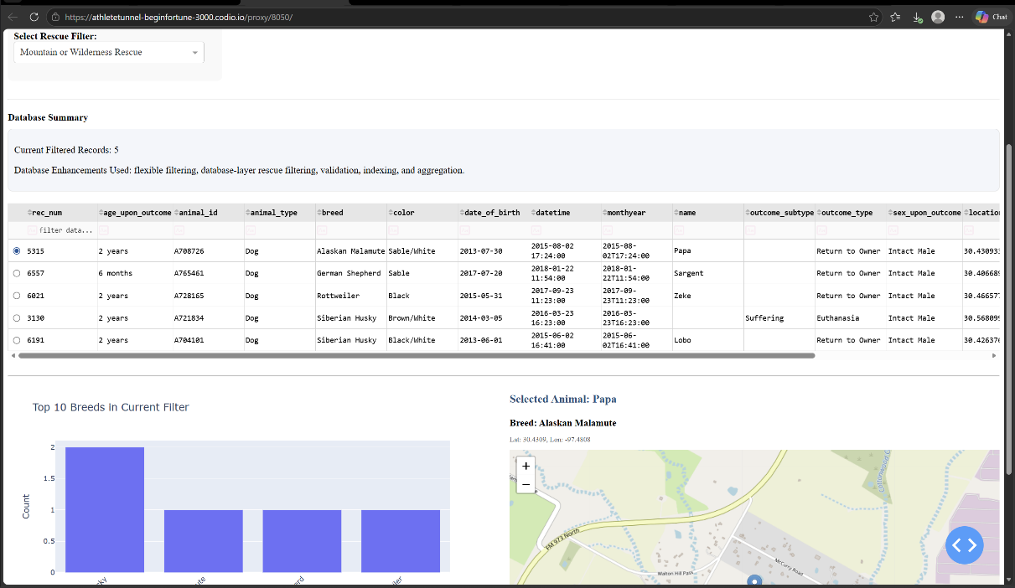
Complete dashboard interaction example demonstrating integrated functionality between the MongoDB database, filtering system, interactive table, graph visualization, and geographic mapping components.

Figure 7: Enhanced CRUD Python Module
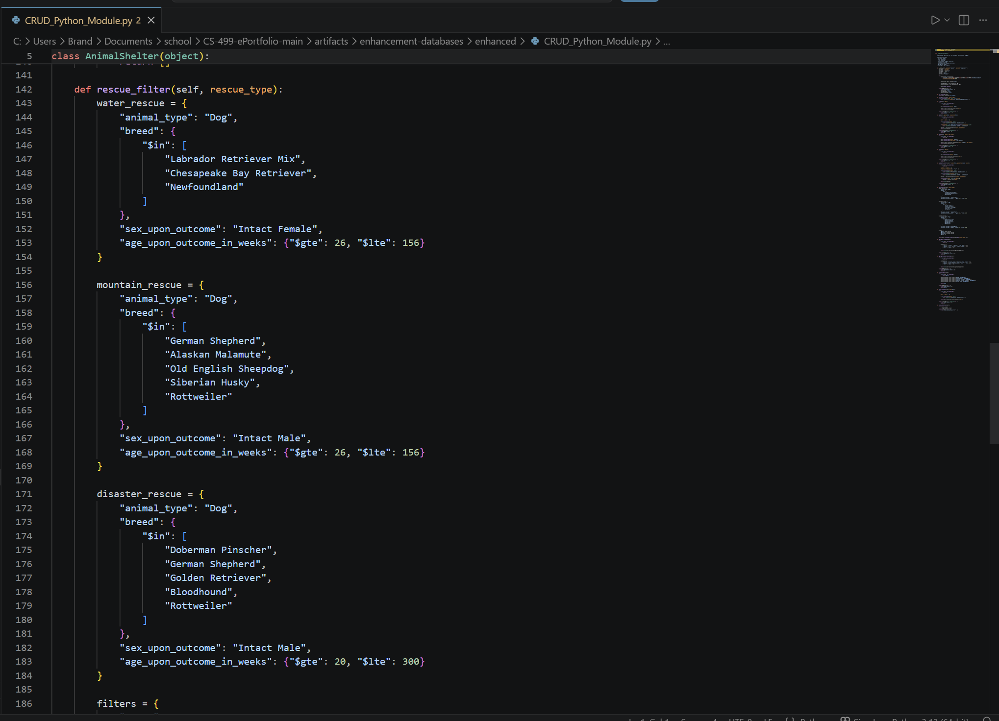
Enhanced CRUD Python module demonstrating reusable filtering methods, aggregation support, validation logic, indexing, and improved database-layer organization.

